**TITLE**

*A. Jablonski1, G. Stokes2*

1Affiliation

2 Affiliation

*e-mail: Stokes@email.com

**Format:** Microsoft Word (*.docx).

**Margins**: 2.5 cm. **Font**: Book Antiqua, single line spacing.

**Title**: bold 12 pt, alignment – centered. The indentation is 12 pt.

**The names of the authors**: Italics 12 pt, alignment – in the center, the last name of the speaker is underlined. The indentation is 6 pt.

**Organization(s)** (only the names of organizations without their addresses) and e–mail address: regular 12 pt, alignment - centered. The indentation is 12 pt.

**Text**: 1 full page, regular 12 pt, width alignment, without indentation of the paragraph.

**References**: the usual 12 pt, the title of the journal in italics, the volume in bold.

**Figures** should be inserted into the text **without wrapping**.

**The title of the picture**: under the pictures, the usual 12 pt, alignment – in the center. The indentation is 6 pt.

**Acknowledgements** for financial support should be indicated under the main text, in italics 12 pt.

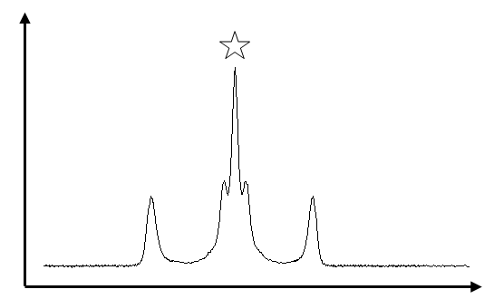

Fig. 1. Title

Lorem Ipsum is simply dummy text of the printing and typesetting industry. Lorem Ipsum has been the industry's standard dummy text ever since the 1500s, when an unknown printer took a galley of type and scrambled it to make a type specimen book. It has survived not only five centuries, but also the leap into electronic typesetting, remaining essentially unchanged. It was popularised in the 1960s with the release of Letraset sheets containing Lorem Ipsum passages, and more recently with desktop publishing software like Aldus PageMaker including versions of Lorem Ipsum.

*The work was financed by the Fund (project No. 00-00-00000).*